|  |  |
| --- | --- |
| Exercise 3 | For loop |

In this case you are required to make the application to accept an input, validate the input and print out the number.

When user input a number, print out the list of even and odd number within the range of the input number.

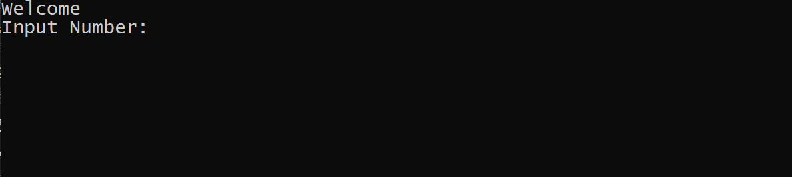

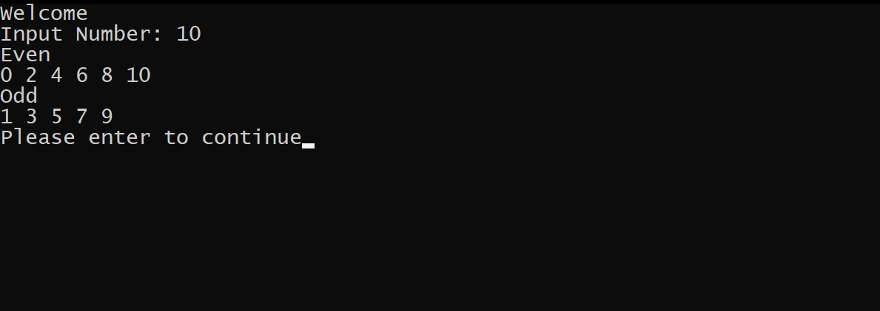

Validate the input if it’s not integer then output a message

